Chap 7. Thermal Insulation and Moisture Barrier 絕熱與絕濕

7-1. Introduction

農用設施中使用絕熱材料不只是考量其在節約能源上的效果，其尚影響所需額外加熱的程度、動物所處的輻射熱環境、牆面與牆內的水份凝結問題等。

7-2. Optimum Insulation Thickness

農用設施中使用絕熱材料的厚度提高則可節約許多能源，降低能源成本，但也同時會增加安裝的成本。兩者同時考量，某厚度的總成本為最小，此厚度即為最佳厚度。厚度與安裝成本不是呈線性增加，材料與工資皆然，通常在某個範圍之外，在價位上會有個激增(step increase)，如圖所示。

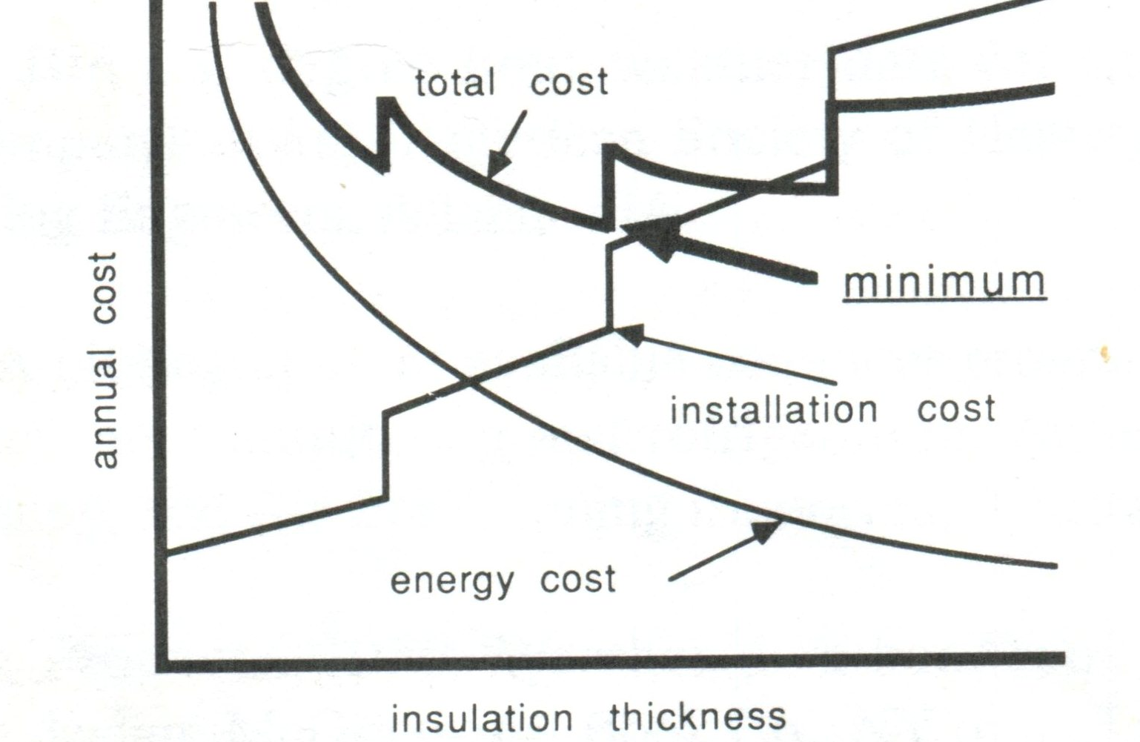

Eq.7-1 所示為利用Bin Data 評估全年所需之加熱量的方法，其中 tout 為各段溫度區間的平均值。

q_{heat} = ΣUA(tin-tout)(hours in the temperature range) ...........(7-1)

另一種評估方法可利用heating Degree Day的氣象資料。其以外溫為65度F(18.3度C)為計算基礎。研究發現一整天的熱損失量與外溫與18.3度C的差成比例關係。外溫為8.3度C與13.3度C，室內欲維持整天都在24度C，二者所需的加熱能源前者為後者之兩倍。P.415 Appendix 7-1所示為全美各地的heating Degree Day(HDD)。Eq. 7-2所示為計算全年所需之加熱量的方法，其中HLF為heat loss factor, 包括 ΣUA+FP+mCpΔt，最末項代表通風(ventilation)或漏風(infiltration)的影響。K為經驗參數，計算一般家庭的加熱成本時以0.6至0.8為K值。此K值同時代表以18.3度C為基準的誤差程度。Eq 7-3所示為計算全年所需加熱成本之方法，η與HVF分別為加熱系統之效率與使用燃料之熱值。

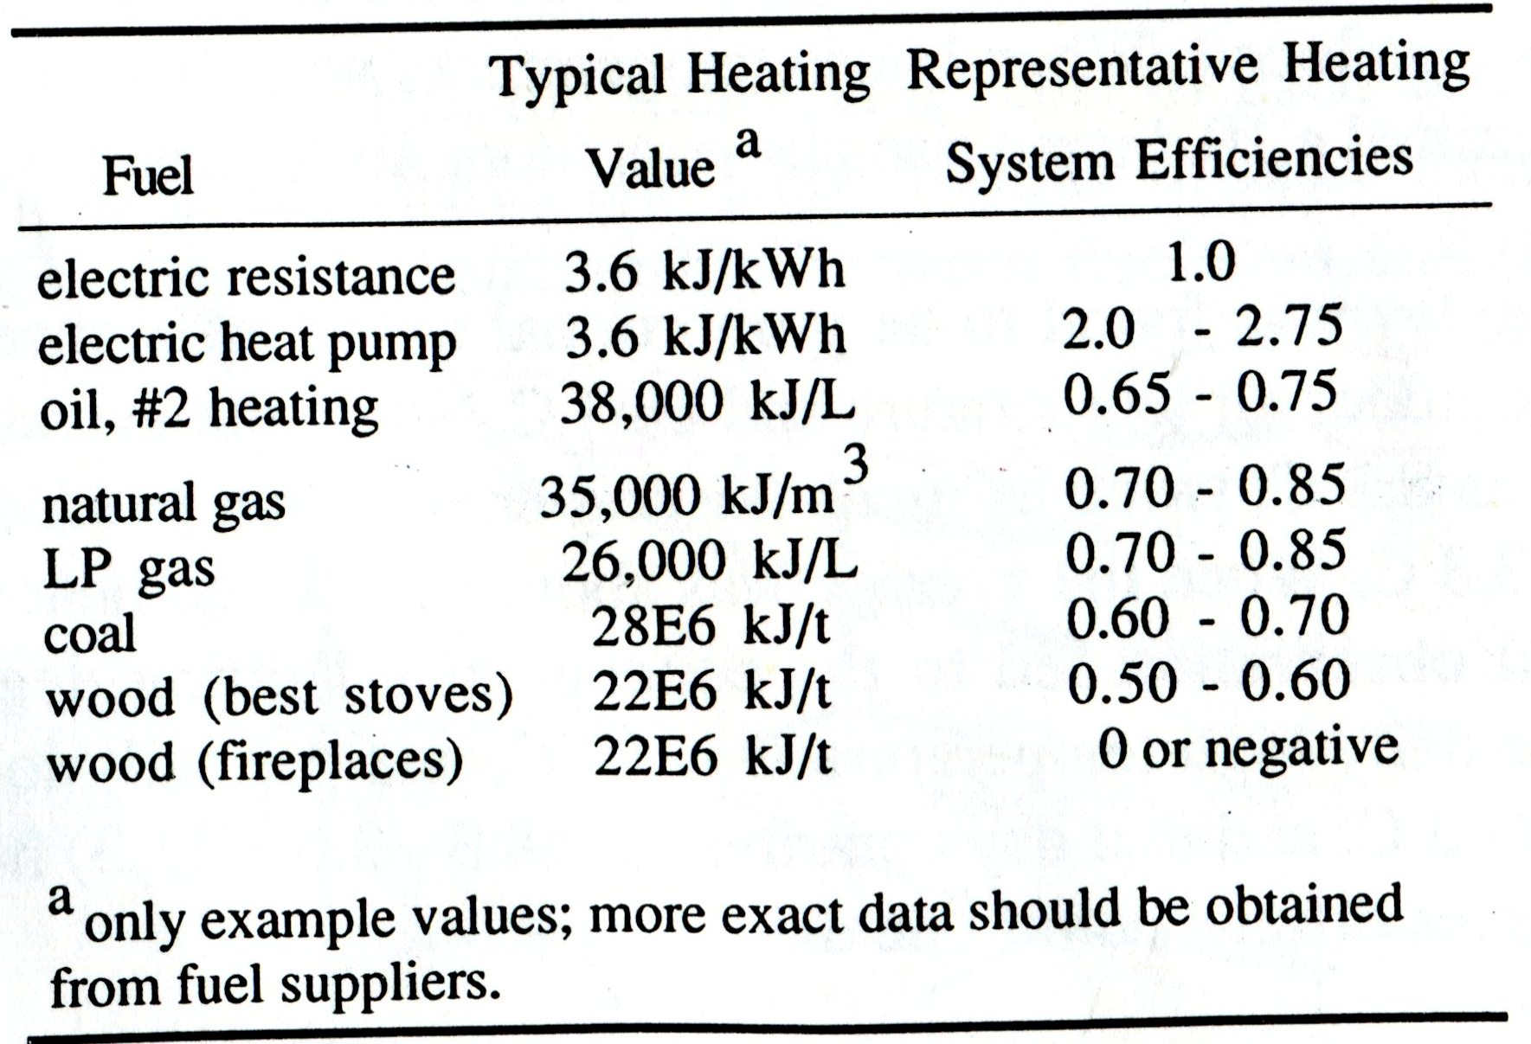

Example 7-1. Estimate the yearly cost to heat a single family home in a region characterized by 4000 heating degree days (base 18.3 C). The home’s heat loss factor (HLF) is 650 W/K, the correction factor K is estimated to be 0.7, and #2 heating oil will be used with an estimated heating system efficiency of 0.75. The oil costs $0.25/L.

q _{heating} = 24(HLF)(HDD)(K) = 24 (650) (4000) (0.7) = 4.4E7 W-hr = 1.6E8 kJ
q_{value} = (1.6E8 kJ)($0.25/L)/(0.75)(38,000 kJ/L) = $1400/year

Example 7-2. A design engineer faces the problem of determine the optimum thickness of foam board insulation to install on the inside surface of the foundation wall of a greenhouse. The wall is concrete block with a basic R-value of 0.35 m²K/W (the R-value with no insulation on the wall, but including the surface thermal resistances). The greenhouse is to be located near Lansing, Michigan.
Natural gas is the heating fuel and is expected to cost $0.20/m³ (today’s dollar, with fuel inflation equal to the generation inflation rate) during the life of the insulation. The annualized cost of installing the insulation has been estimated to be

Thickness | Annual Cost, $/m² | R-value, m²K/W
0mm  12.7  25.4  50.8  76.2  101.6 | 0  1.75  2.50  4.50  9.50  11.50 | 0  0.55  1.10  2.20  3.31  4.41

The greenhouse will be heated to a constant air temperature of 21.1 C. (Typical practice is to have day and night temperature settings which differ, but for simplicity in this example assume constant indoor air temperature.)

q_{15.6-21.1} = UA(21.1 C – 18.35 C)(1466 hr)
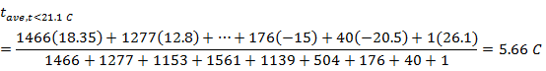
q_{heating} = UA(21.1 C – 5.66 C) (7317 hr) (3600 s/hr) (0.001kJ/J)
q_{heating} = 1.162E6kJ/m²
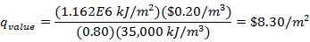

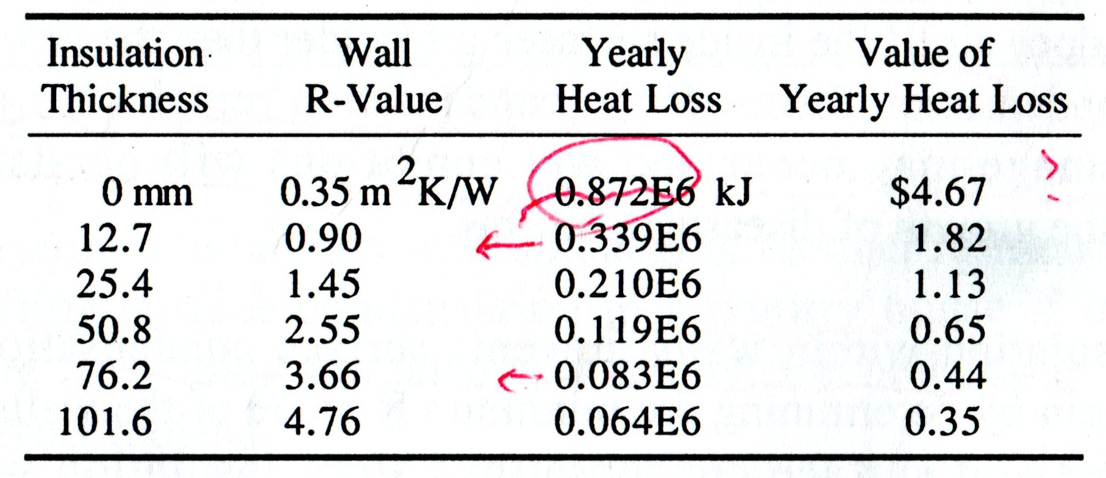

7-3. Condensation on Wall Surface

內溫 (t_{i}) > 內壁溫 (t_{is}) > 外壁溫 (t_{os}) > 外溫 (t_{o})

- 當牆壁的絕熱不佳時，內壁溫接近外溫，造成內溫與內壁溫有很大的溫差，一旦後者低於前者的露點溫度，則在牆壁內側表面即會發生水滴凝結。
- 提高牆壁的絕熱性，使內溫與內壁溫的差異減小，可有效防止在牆壁表面發生水滴凝結。關鍵在使t_{is} > t_{dp}。
- 類似觀念：杯子裝冰水，杯子外壁結露，就是因為杯子外壁表面溫度低於空氣的露點溫度。此時內溫 (t_{i}) < 內壁溫 (t_{is}) < 外壁溫 (t_{os}) < 外溫 (t_{o})
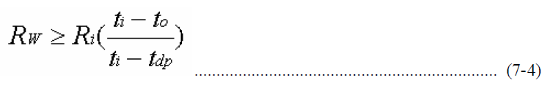
其中，Rw 為整個強的熱阻(thermal resistance of the entire wall)

Example 7-3
Determine minimum wall and ceiling thermal resistance to prevent wall and ceiling surface condensation in a poultry house if indoor design conditions are 22 C and 75% relative humidity; the building is to be located near Fort Wayne, Indiana.

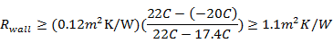
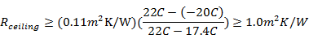

7-4. Condensation Within Walls

能量的傳導基於溫差，水份的傳導則源自兩側水蒸氣分壓的壓差。當外溫甚低時，加熱的室內其水蒸氣分壓必定甚高於外界，所以水份一定會逐步的往外擴散(diffuse)。
使用絕熱材料於牆壁中將使外壁溫還低於未使用絕熱材料時的外壁溫。較低溫時的飽和蒸氣壓為較低，於是水份更容易凝結。如上圖所示，在靠近外壁的內側即開始有水份凝結，此表示在較溫暖高濕的一側的牆內加裝一層防水的材料是必需的。

7-4.1. Wall Vapor Diffusion

Fick’s Law： w = -μ(dp / dx) ..........................................(7-5)
其中， w:單位時間單位面積擴散過的水量
μ: 水份擴散率(permeability)

w = -μ(p1 – p2)/L....................................................................... (7-6)
其中， μ/L: 水份擴散係數(permeance)，單位: ng/s-m2-Pa = perms
L/μ= RH2O: 水份擴散阻力(resistance)，單位: TPa-m2-s/kg = reps

10 perm (IP，英制) = 574 perm (SI，公制)

p.417 的Appendix 7-2 所列為一般建材的水份擴散係數(permeance)與水份擴散阻力(resistance)。
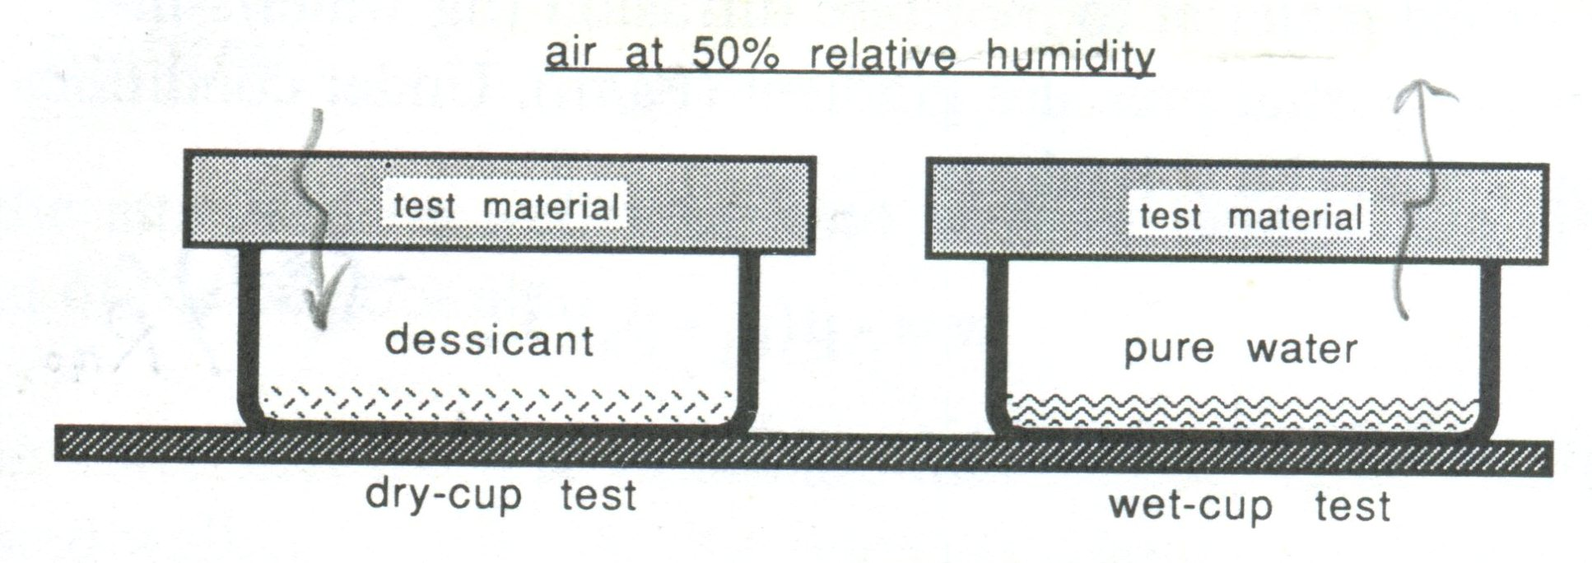
Example 7-4
A wood-framed wall is constructed using 15.9 mm thickness Douglas fir plywood as outside siding, 12.7 mm thick sheathing quality structural insulating board, 88.9 mm mineral wool backed with asphalt impregnated paper, and 15.9 mm thick gypsum wallboard as inside sheathing. The inside surface of the wall is painted using a latex prime-sealer and one coat of a semi-gloss vinyl acrylic, the outside surface has accumulated three coats of white lead and oil paint.
Indoor conditions are expected to be 20 C and 40% relative humidity and design conditions for weather are – 20 C and 60% relative humidity. The building is located at an altitude of approximately 500 m.
Estimate the flux of water vapor diffusing through the wall under these conditions.

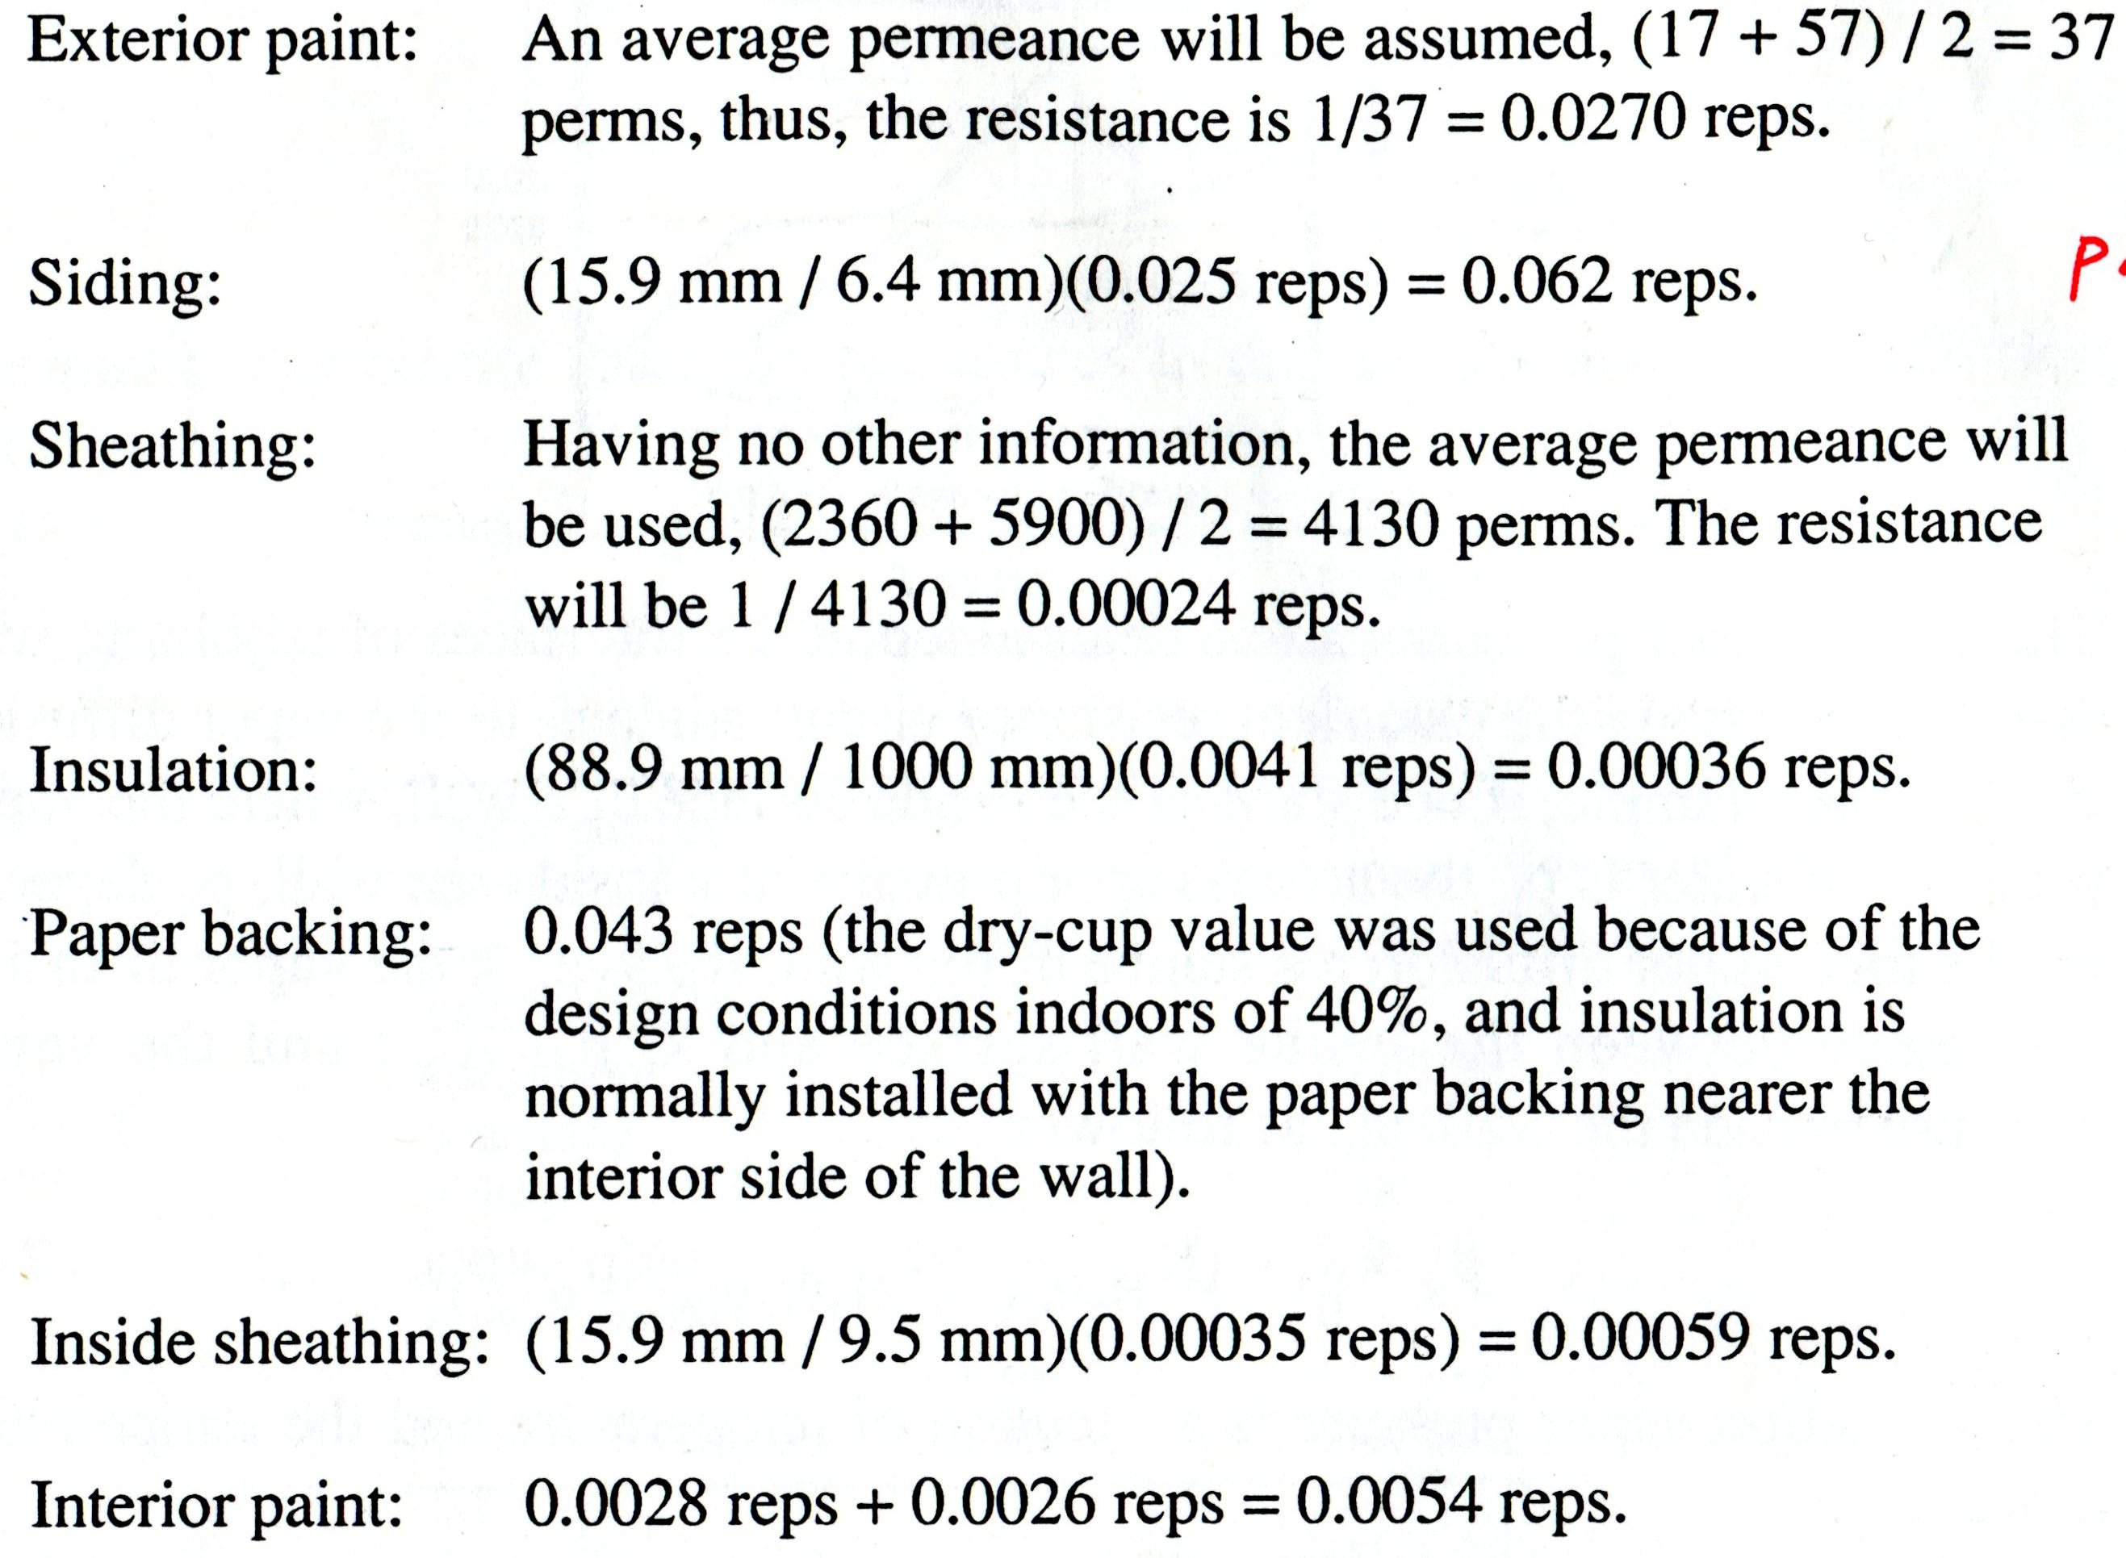
R_{H2O} = 0.0270 + 0.062 + 0.00024 + 0.00036 + 0.043 + 0.00059 + 0.0054 = 0.13859
w = (p_{i} - p_{o}) / R_{H2O} = (0.95E – 9TPa – 0.06E – 9TPa) / 0.14 reps = 6.4E – 9kg/s-m²

7-4.2. Condensation Rates

要預測冷凝在何處發生必需依賴如下圖所示的分析，必需將各交接面的實際與飽和蒸氣壓值予以繪出。實際蒸氣壓值可透過Eq.7-7 的計算，飽和蒸氣壓值則需透過Eq.7-8 先求出溫度，再透過類似PLUS 的程式求出該溫度下的飽和蒸氣壓值。
p_{x} = p_{i} + (R_{H2O}, x / R_{H2O}, total)(p_{o} – p_{i}).................................. (7-7)
t_{x} = t_{i} + (R_{thermal}, _{x} / R_{thermal}, _{total})(t_{o} – t_{i})............................... (7-8)

Example 7-5
Determine whether condensation can be anticipated within the wall described in Example 7-4, and if so, where.

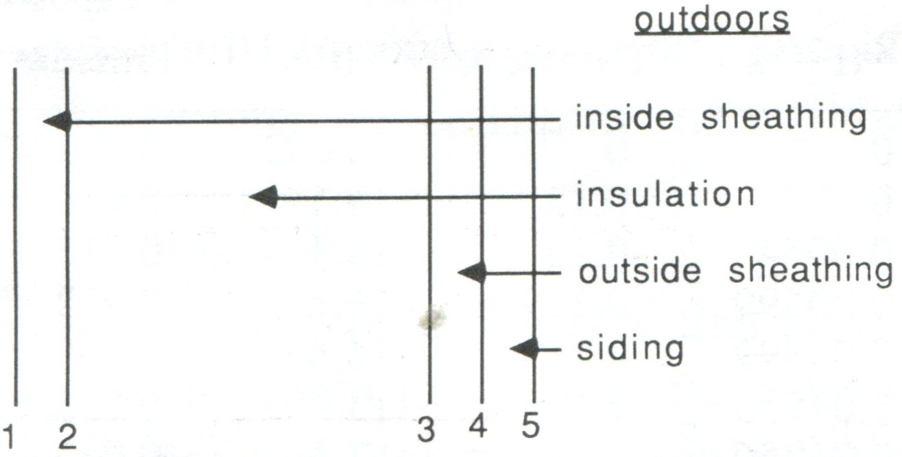

7-4.3. Vapor Retarding Barriers

防水材料需安裝在較溫暖的一側，有用石化纖維做成的絕熱材料以柏油紙做背襯當防潮用，紙後又加一層鋁箔加強防潮效果。然而，此類防潮材料再施工時容易因施工不當而撕破或產生穿孔而喪失防水效果，一般常用的仍然以軟質的PE(Polyethylene)為主。Eq. 7-10 由 Eq.7-9 所導出，Radded 為防水材料所需的水份擴散阻力， Roriginal 為未使用防水材料時的水份擴散阻力。

上式中，Px 為在x section 不會造成水分凝結的情況下所允許的最大蒸汽壓，換言之，即為在該位置的飽和蒸汽壓值。式7-10 可用在每個可能有水分凝結發生的Section，重複計算Radded 取最大者使用。

Example 7-6
Continue with the wall section of Example 7-4 and determine the vapor diffusion resistance (rep value) required for a vapor retarding barrier at 2(a) to prevent condensation within the wall.

Chap. 7 Homework
- A poultry house is to be designed and the maximum relative humidity is to be 70%. Develop a graph to show how the required minimum R-value of the walls to prevent condensation on the indoor wall surface varies as a function of the design minimum outdoor air temperature. The outdoor air temperature should be graphed on the x axis, and the range should be from – 40 C to – 10 C.
- A single family home is to be built in a region characterized by 4800 heating degree days (base 18.3 C). The walls are to be constructed of concrete blocks, with bricks on the outside and insulating foam covered by gypsum wallboard on the inside. Heat will be by #2 fuel oil and a new, high-efficiency furnace will be used having a seasonal efficiency of 90%. Oil prices are expected to be approximately $0.30 per L.
Assume the R-value of the components of the wall less the foam will be 0.6 m2K/W, the foam board has a thermal conductivity of 0.018 W/m K, and its cost will be the same as listed in Example 7-2. Determine the most economical thickness of foam insulation to use.
- Consider the wall described in Example 7-4. The only change is that the outer surface has been painted with a latex primer-sealer and one coat of a semi-gloss vinyl acrylic. The wall is part of a single family home located in a very hot and humid climate. The indoor air will be conditioned to 24 C and 60% relative humidity, and outdoor design conditions are expected to be 38 C and 70% relative humidity. Graph the temperature profile, the actual vapor pressure profile, and the saturation vapor pressure profile through the wall. Will there be condensation within the wall? If so, determine the rep value of the vapor barrier required to prevent condensation.

