Chapter 10 Ventilation Control and Quantification of Performance
通風控制與降溫效果量化指標的建立

10-1. Introduction

右圖所示為控制系統示意圖，A為室內溫度，B為室外溫度，T為溫度調節器(Thermostat，又稱恆溫器，包括感測、設定與輸出等三個動作)，H為加熱器。
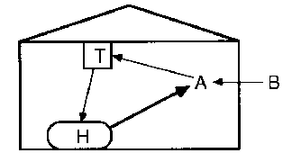

一般包括加熱與通風的溫度控制系統如圖10-1所示，外溫與室內之其它熱源影響建築物之散熱情況，直接影響內溫。內溫與恆溫器之設定值控制通風口、風扇與加熱器之開閉。通風口、風扇與加熱器對室內溫度的影響屬於負回授(饋)控制(negative feedback control)，負回授(饋)代表此次的動作幅度愈大，下次所需的動作幅度則愈小。

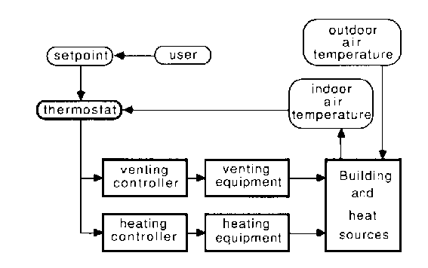
常見的回授(饋)控制包括：
On/Off Control | Simple, Less accurate, Overshoot
比例控制  Proportional control | The rate at which the controlled parameter is delivered is proportional to the difference between the reference input and the controlled output.  This applies correction in proportion to the size of the error.
積分控制  Integral control | Limits small long-term offsets from set-points. Acts to integrate error over time and bring the average error to zero.  This applies correction in proportion to the integral of the error.
微分控制  Derivative control | DC is used when a rapid response is desired. The time derivate of error determines the magnitude of the response. DC is useful to prevent sudden large departures of the controlled variable from the setpoint.  This applies correction in proportion to the rate of change of the error.
$$p=K_{p}E_{p}+K_{p}K_{t}\int{E_{p}\text{dt}}+K_{p}K_{D}\frac{{\text{dE}}_{p}}{\text{dt}}+P_{t}\left(0\right)$$

10.2. Duty Factors, staged fan systems using single speed fans

相對於單速風扇的就是有允許調整風速的變頻風扇，本節所述所有計算都是針對使用單速的風扇。風機系統的Duty Factor 定義為全年的平均風量率(m³/s)除以該系統的最大風量率。如果風機系統的Duty Factor與風機之效率為已知，則風機之全年使用成本即可計算求得。
常見的控制策略有三種：第一種是依據室內溫度做控制，以圖10-2 (下方左圖)為例，使用三個Thermostat (恆溫器) 設定三個室內溫度值，控制4個風量。圖10-3 (下方右圖) 所示為第二種方式，依據室外溫度做控制，其平均風量率與外溫呈平滑函數關係。第三種則為如表10-1所示的方法，也是依據室外溫度。
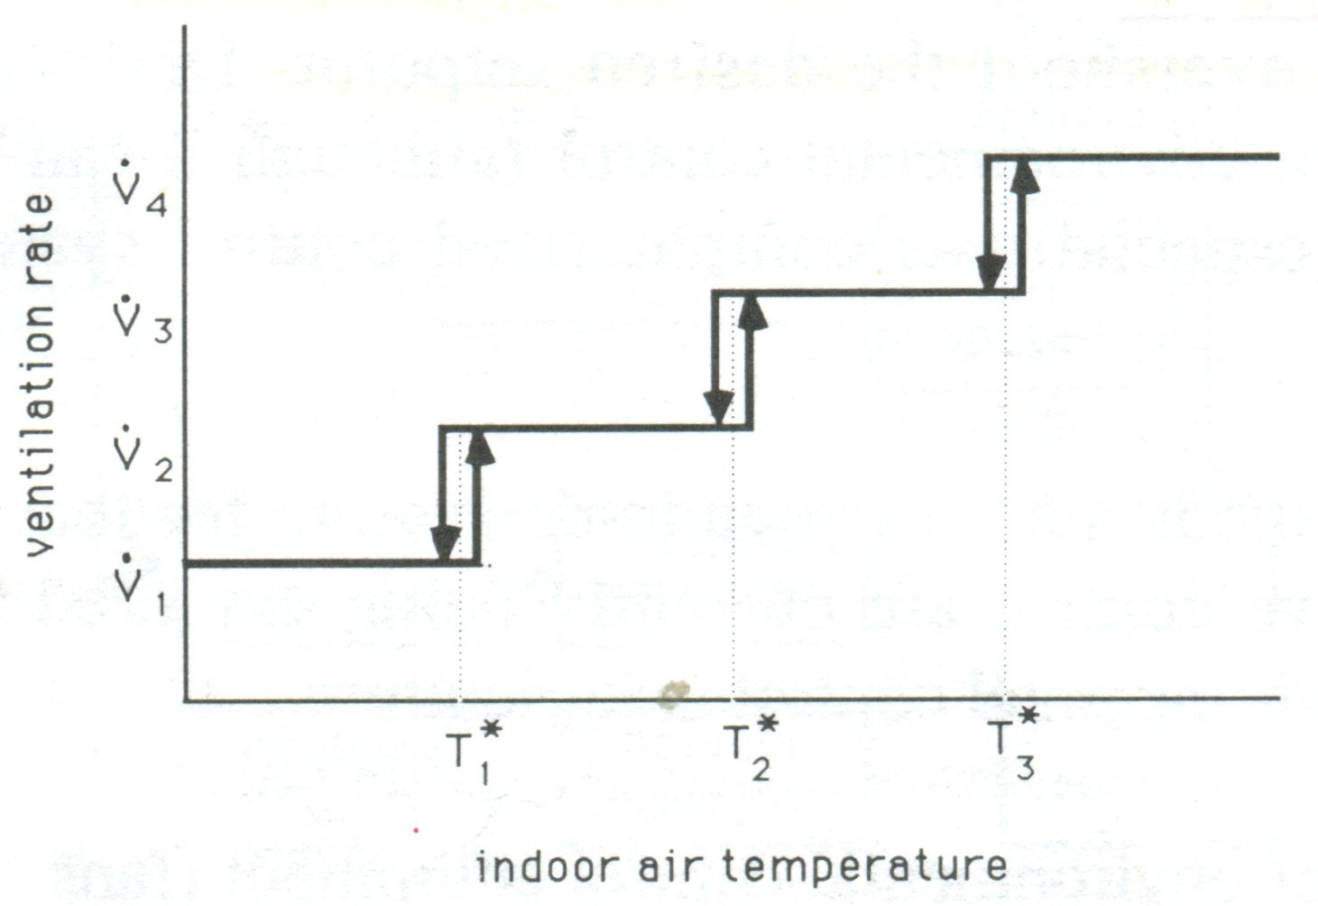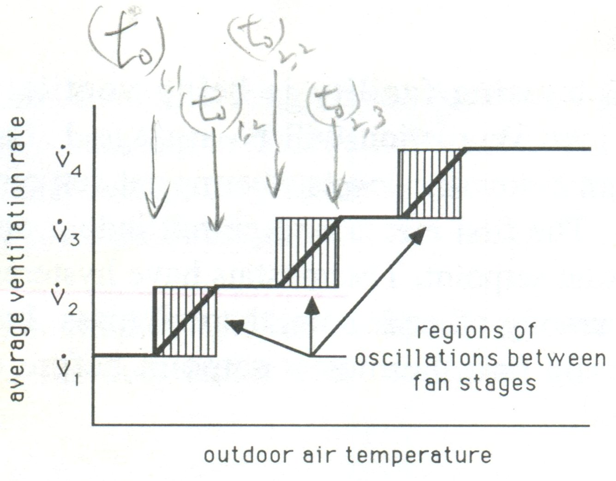
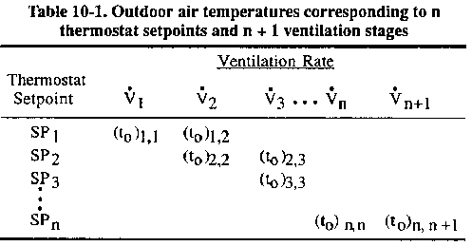

上表中 t_{o}可用式10-1計算，其中動物所提供之顯熱改用式10-2的一元二次式表示(可使用POLYNOM程式求出a, b, c係數之值)，經重組得式10-3可用來計算 t_{i}，得式10-4可用來計算 t_{o}。
$t_{0}={\left[−q_{\text{prod}}+\left(\sum{\text{UA}+\text{FP}+{\text{mc}}_{p}}\right) t_{i}\right]}/(\sum{\text{UA}+\text{FP}+{\text{mc}}_{p})}$ ……………………………….(10-1)
$$\text{HLF}=\sum{\text{UA}+\text{FP}}$$
$$t_{0}={\left[−q_{\text{prod}}+(\text{HLF}+{\text{mc}}_{p}) t_{i}\right]}/(\text{HLF}+{\text{mc}}_{p})$$
……………………………………………………………………….(10-2)
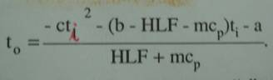.. (10-4)
$$c t_{i}^{2}+ (b−\text{HLF}−{\text{mc}}_{p}) t_{i}+[a+(\text{HLF}+{\text{mc}}_{p}) t_{0}]= 0$$
…………………….(10-3)

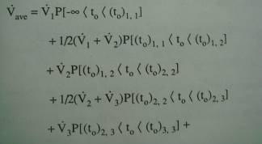 (10-6)
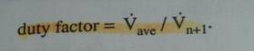 (10-7)

10-3. Ventilating Efficiency Ratios and the Cost of Ventilation

冷凍空調系統的性能係數/日本稱為成績係數COP (Coefficient of Performance) 為無因次指標，用於製冷/製暖的COP分別以COP_{c} / COP_{h}表示。
在完全絕熱的狀況下，COP_{h} = COP_{c} + 1。
COP_{c}= 4代表消耗 1 kW 的電力，可以吸收 4 kW 的熱，此時 COP_{h} = 5。
業界常用的為EER (Energy Efficiency Ratio)，有多種形式，分子與分母均為習用單位。用於表示EER的常見各不同單位與各種單位之EER 與COP 的轉換常數如下表：

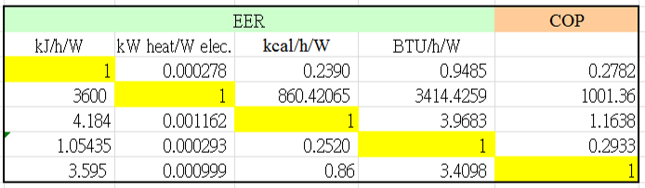

風扇效率的定義與空調系統雷同，只是前者的分子是風量率，後者是能量轉移率。
$\text{VER}=(m^{3}s\text{of}\overset{}{}\text{air}\overset{}{}\text{delivery})/(\text{kW}\overset{}{}\text{of}\overset{}{}\text{electricity})$ (10-8)
$\text{cos}t=\frac{(\text{8760}{\text{hrs}}/{\text{yr}})(\text{max}\overset{}{}\text{capacity})(\text{duty}\overset{}{}\text{factor})(\text{unit}\overset{}{}\text{elect}\text{.}\overset{}{}\text{cos}t)}{\text{Ventilating}\overset{}{}\text{Efficiency}\overset{}{}\text{Ratio}}$ (10-9)
$$=\frac{(\text{8760}{\text{hrs}}/{\text{yr}})(\overset{}{V_{\text{ave}}})(\text{unit}\overset{}{}\text{elect}\text{.}\overset{}{}\text{cos}t)}{\text{Ventilating}\overset{}{}\text{Efficiency}\overset{}{}\text{Ratio}}$$

Example 10-1. 請計算一台風量為 5.5 m³/s 的風扇運作一年的操作成本，假設風扇的 VER 為 8 m³/s-kW，電費為 0.11 US$/kWh 且工作比 (duty factor) 為0.6。
Determine the cost to operate a fan (5.5 m³/s capacity) for a year if the VER is 8 m³/s-Kw, The cost of electricity is expected to be $0.11/kWh, and the expected duty factor is 0.6.

Sol: cost = 8760 * 5.5 * 0.6 * 0.11 / 8 = 397.49 US$ / yr

10-4. The Cost of Ventilating Animal Housing, an Example

Example 10-2. 位於美國科羅拉多州丹佛市的某繫流式牛舍採取機械通風，該牛舍飼養了150 頭平均重量為 550 kg 的乳牛。假設設計的牛舍的包含牆壁、天花板、週邊等的結構熱損失因子總計為 900 W/K，室內照明為 10 W/m²，牛舍地板面積為 1500 m²。最小與最大通風風量率為 2.9 與 21 m³/s，風扇的 VER 為 9 m³/s-kW，每度電費為0.1 US$。請選擇風扇的控制段數與各階段的設定溫度值，並估算全年的通風成本。
A mechanically-ventilated, tie-stall dairy barn is being designed for construction near Denver, Colorado. The bran is to house 150 milking cows, averaging 550 kg body weight. A design has been chosen which results in a structural heat loss factor (walls, ceiling, perimeter, etc.) of 900 W/K. General lighting, designed at approximately 10 W/m², is expected to operate around the clock. The floor area of the barn will be 1500 m².
Minimum and maximum ventilation rates will be 2.9 and 21 m³/s, respectively. Fans are being considered which have a VER of 9m³/s-kW and electricity is expected to cost $0.10/kWh.
Choose fan stages and thermostat setpoints and estimate the yearly cost to ventilate the barn.

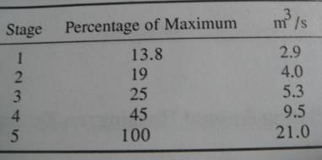
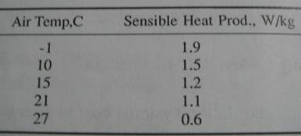
q’_{prod} = 1.8603 – 0.03074 t – 5.268*10^{–4} t² expressed in W/kg for a 500 kg dairy cow.
Transforming q’_{prod} to the entire herd,
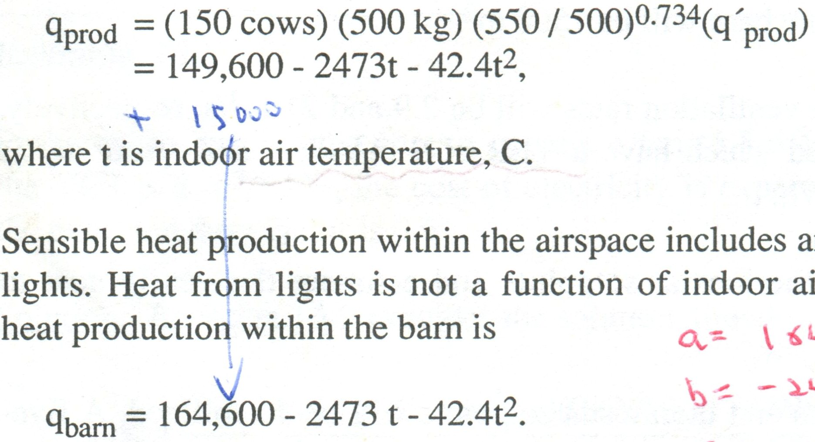

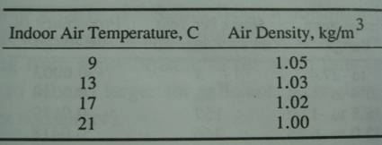
m = (5.3 m³/s)*(1.02 kg/m³) = 5.41 kg/s
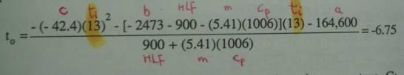
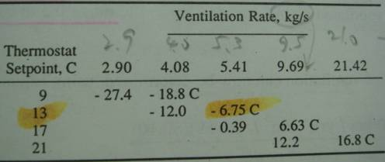

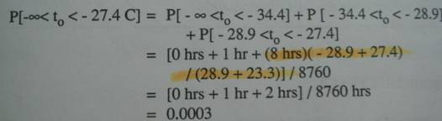

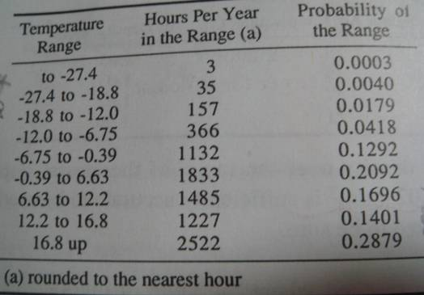
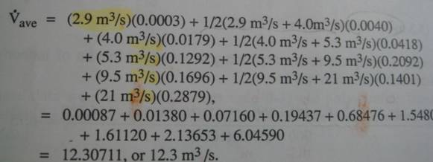
Cost = 8760 * 21 * 0.59 * 0.1 / 9 = $1206, or approximately $8 per cow per year.

10-5. Program DUTYFACT
(10-10)

Example 10-3. 續上題，請使用 Dutyfact 軟體重做上題，另外亦假設風扇分階段採等間隔，請計算通風的成本。
Reconsider the barn described in Example 10-2. Use program DUTY-FACT to calculate the cost of ventilating the barn when the fan staging schedule described in Example 10-2 used, and recalculate the cost when the range of ventilation is segregated into equal increments. Use the default fan data in DUTYFACT to select fans for staging and maintain the setpoints used in Example 10-2.

- elevation above sea level = 1500 m
- ΣUA value = 900 W/K
- FP value = 0 W/K (UA and FP are not separated in the statement of the problem. For convenience, the Heat Loss Factor is consolidated into UA. In the sensible energy balance, the two are added so the consolidation has no effect).
- (a), (b), and (c) are as calculated: 164,600 W, -2473 W/C, and 42.2 W/C².
- The cost of electricity is $0.1 per kWh (somewhat higher than current agricultural rates, if available, but not unusually so).
- The default fan data are not changed.
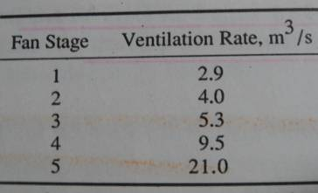 | 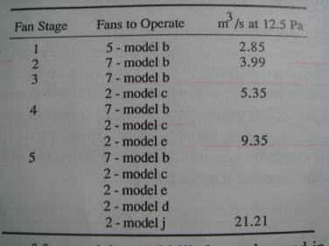
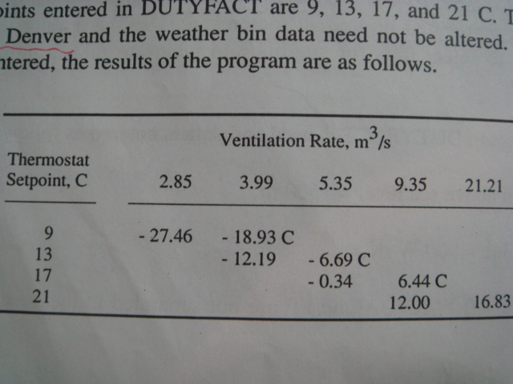
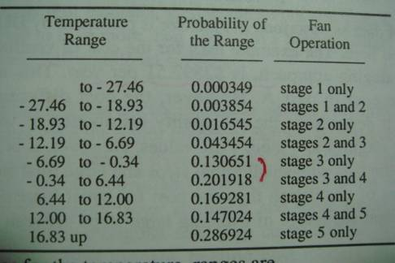

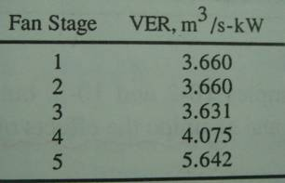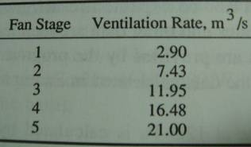
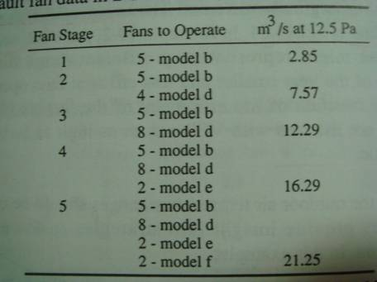

Example 10-4. 續範例 10-2，請嘗試調整各階段的溫度設定值，並討論對通風成本的影響。
Continue Examples 10-2 and 10-3, but in this example use the fan staging of Example 10-2 and examine the effects of changing various setpoints.

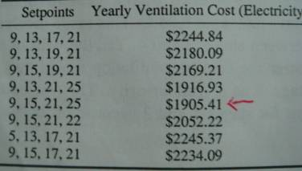

10-6. Quantifying Environment Control Effectiveness

Acceptable Weather Space (AWS)
Climate Space (CS)
Production Space (PS)
Environment-Control Effectiveness Index (EEI)

(10-11)
…………………………………………………………. (10-12)
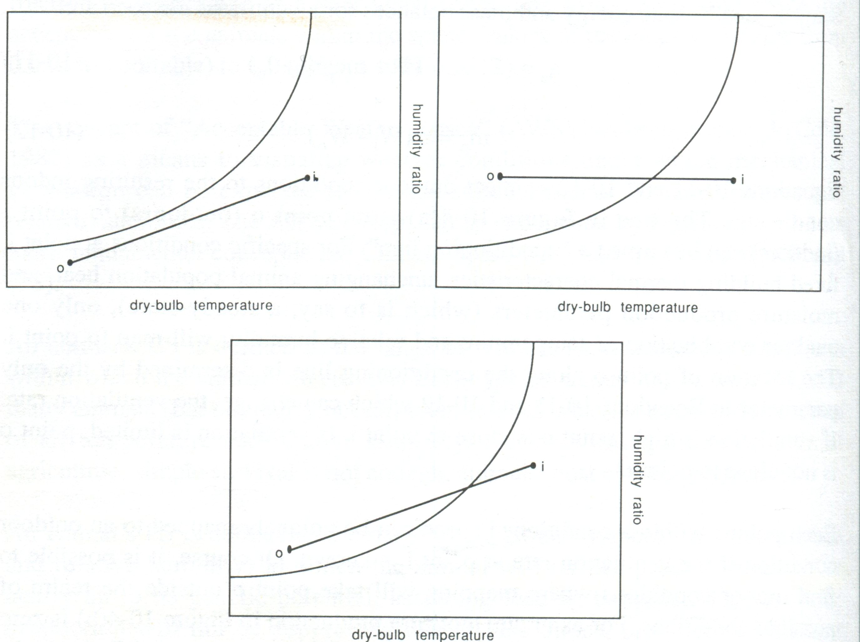

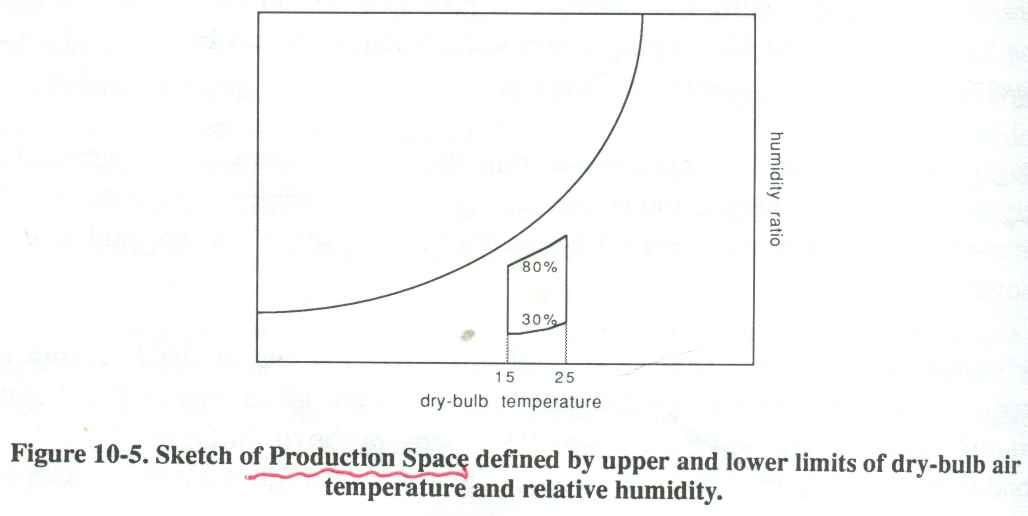
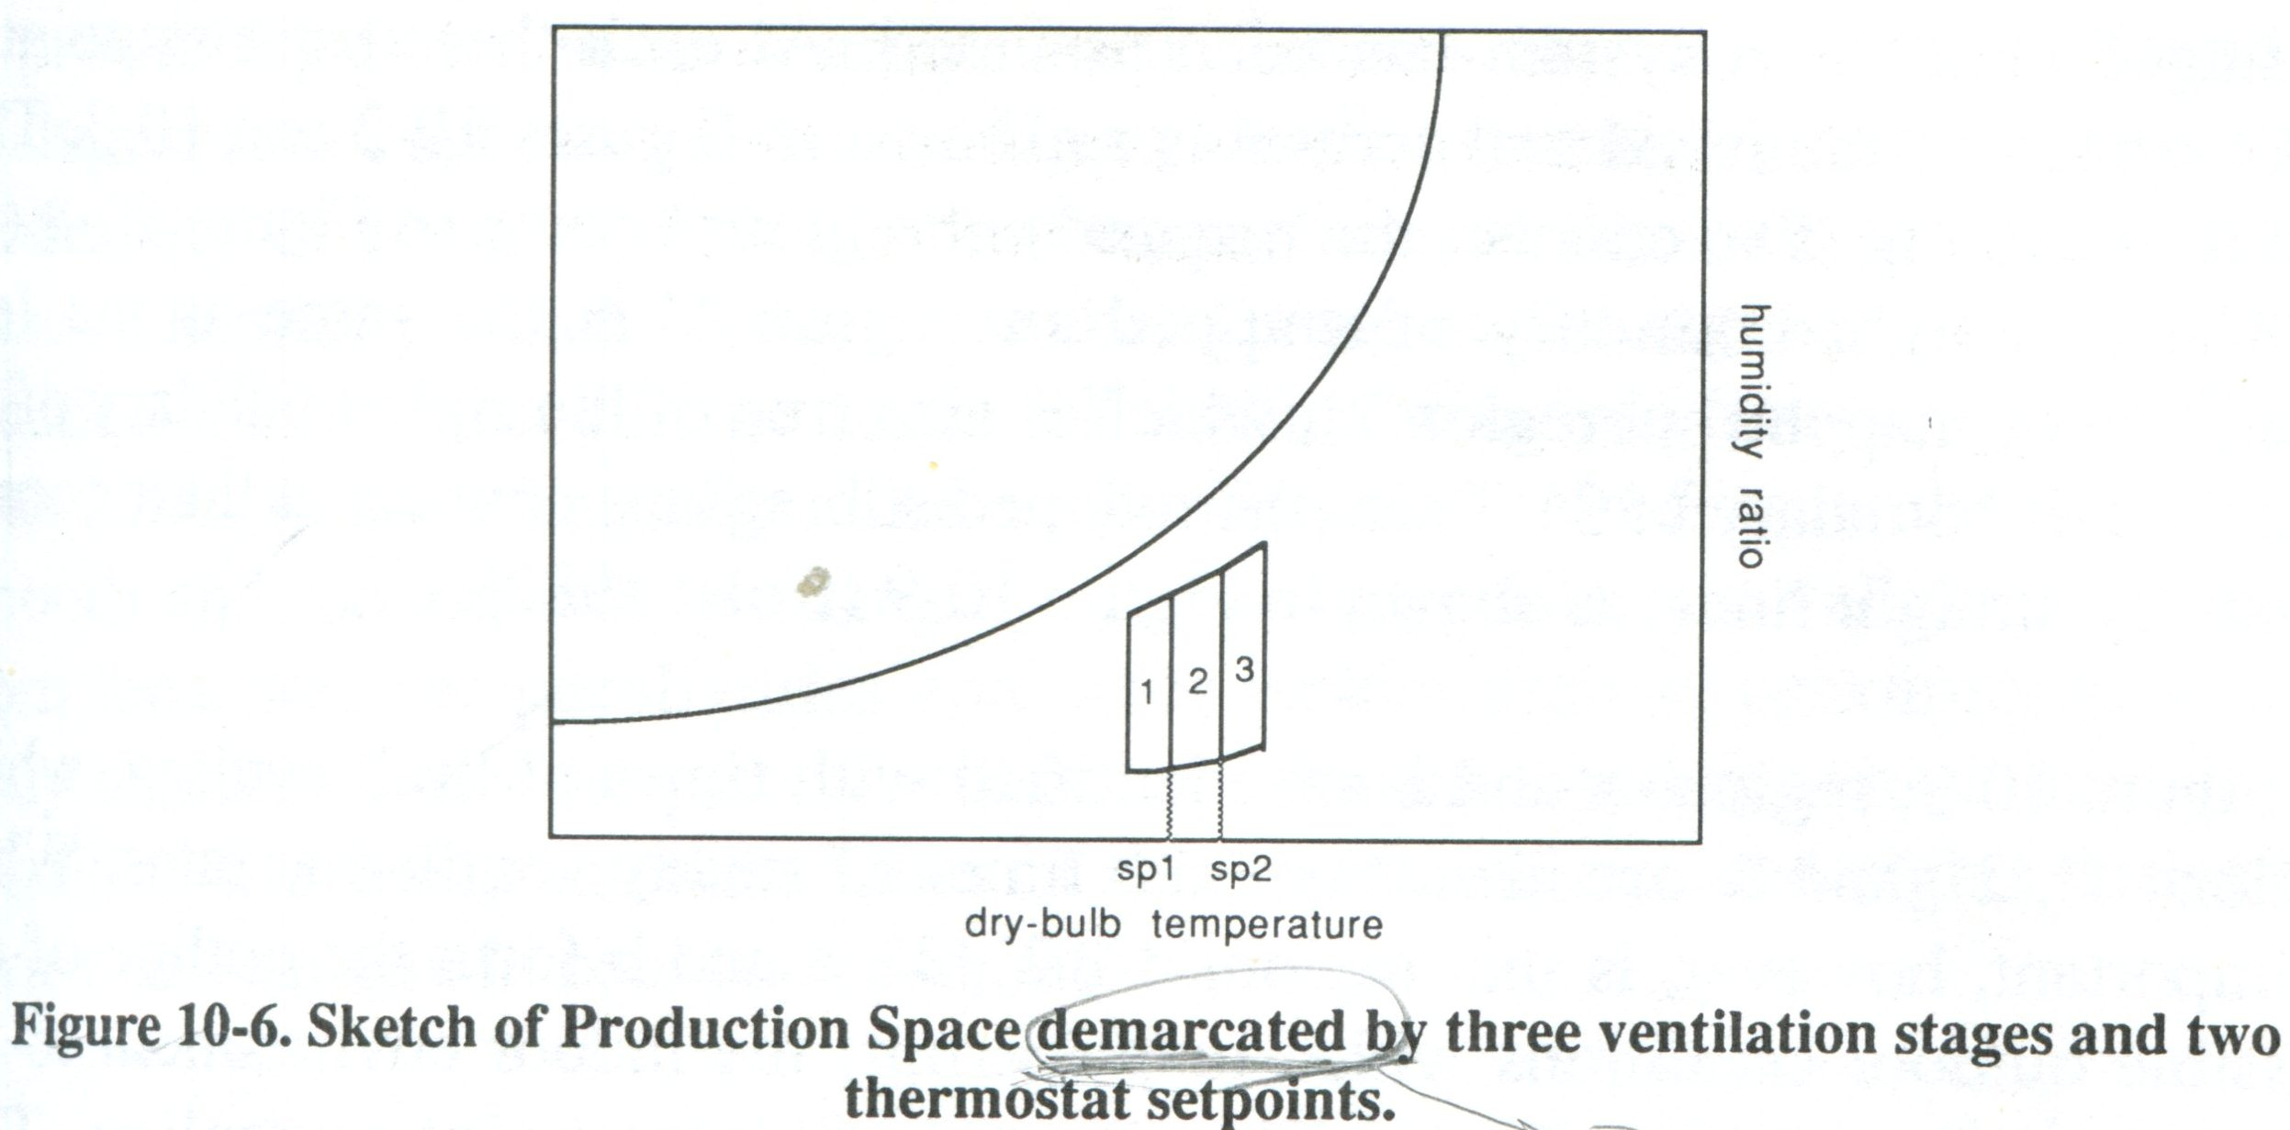
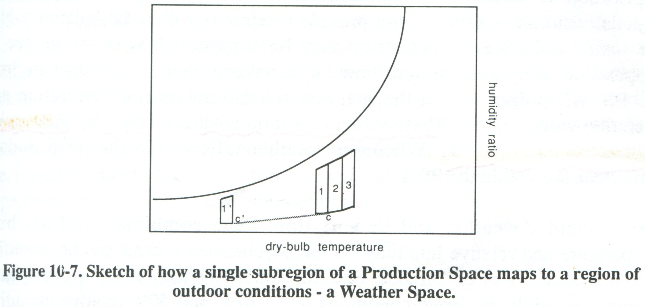
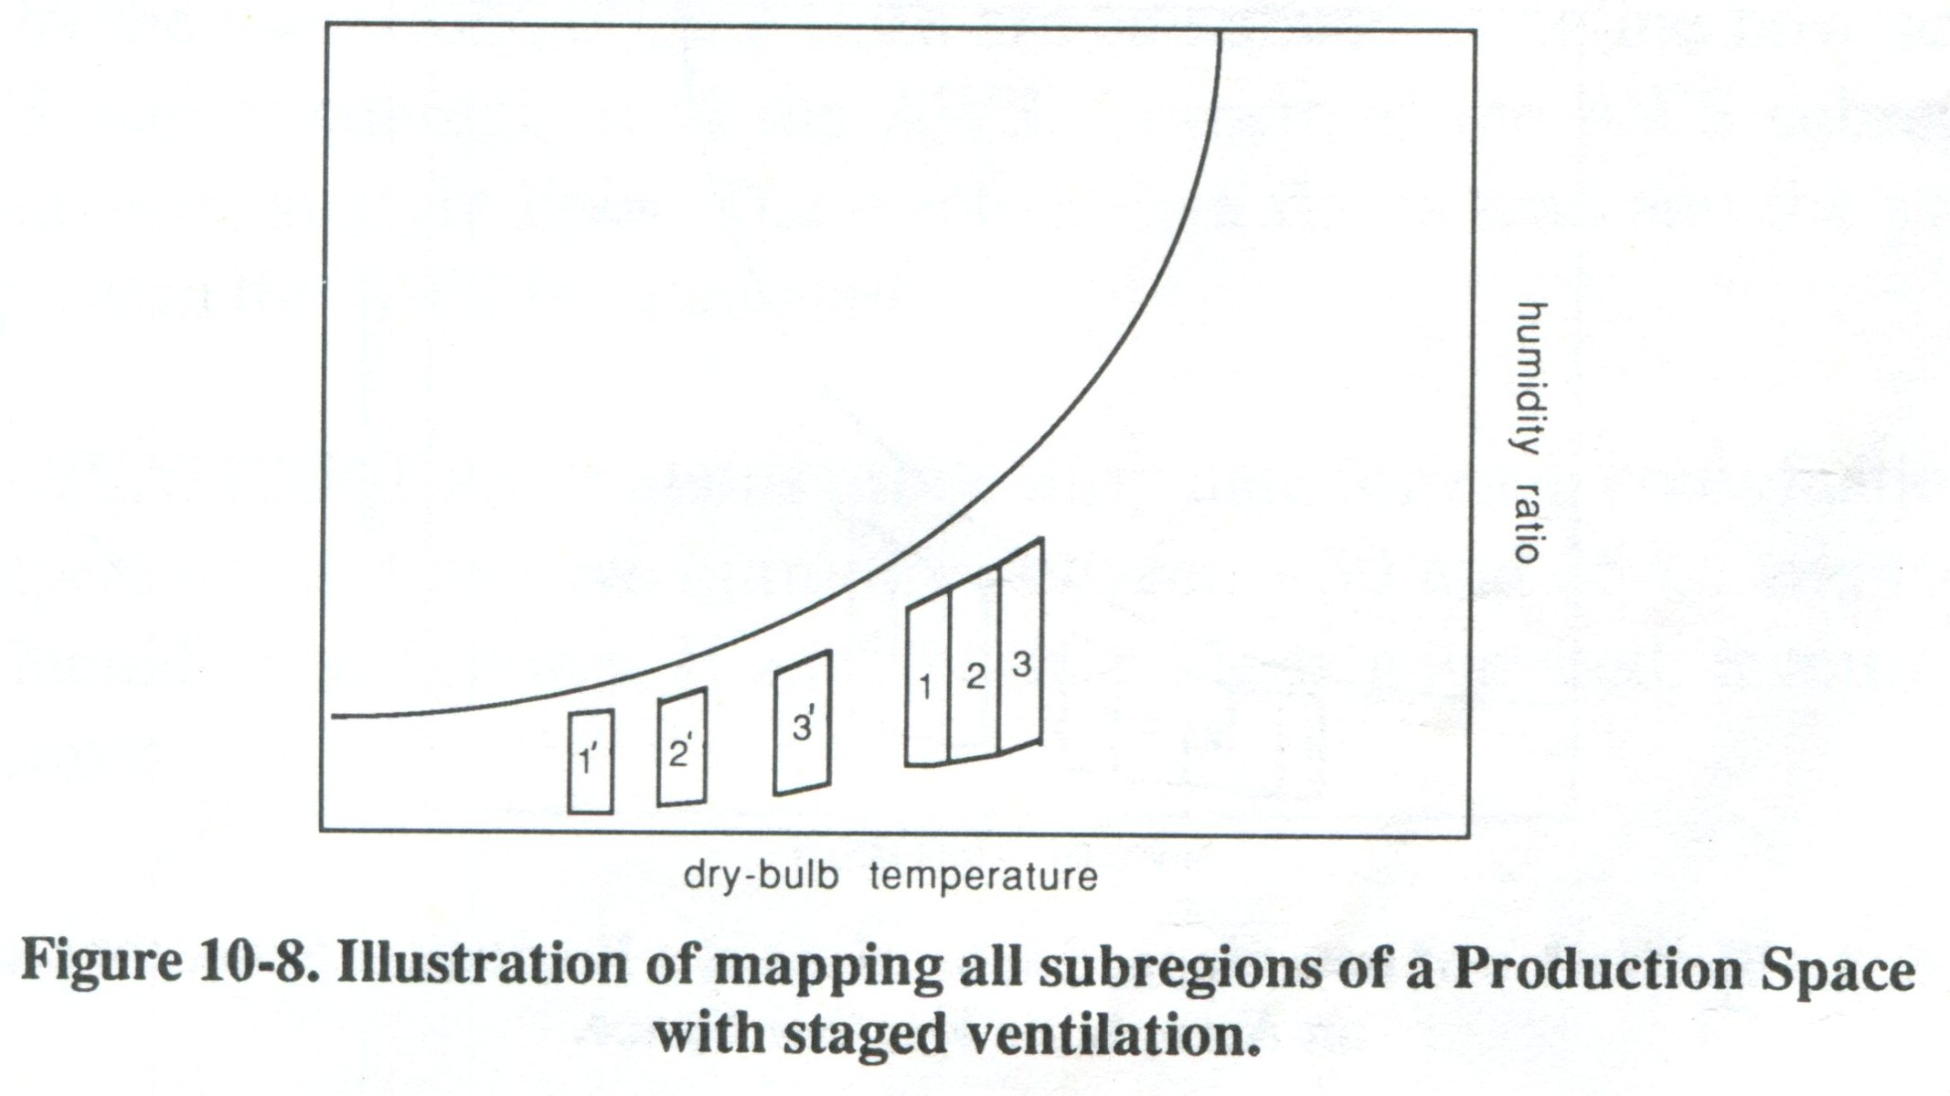
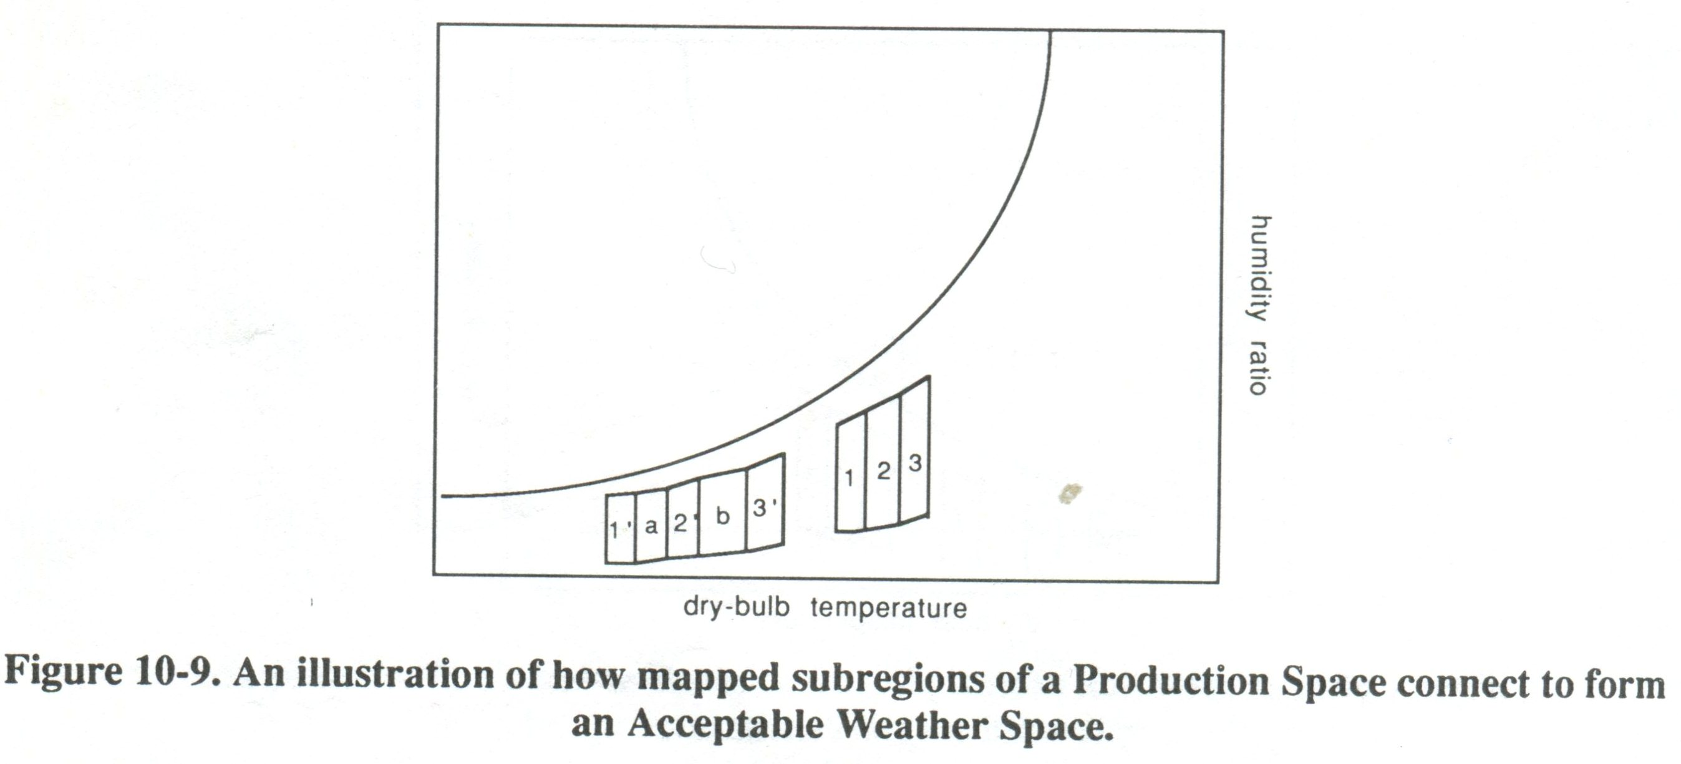

10-6.1. Program WEATHER
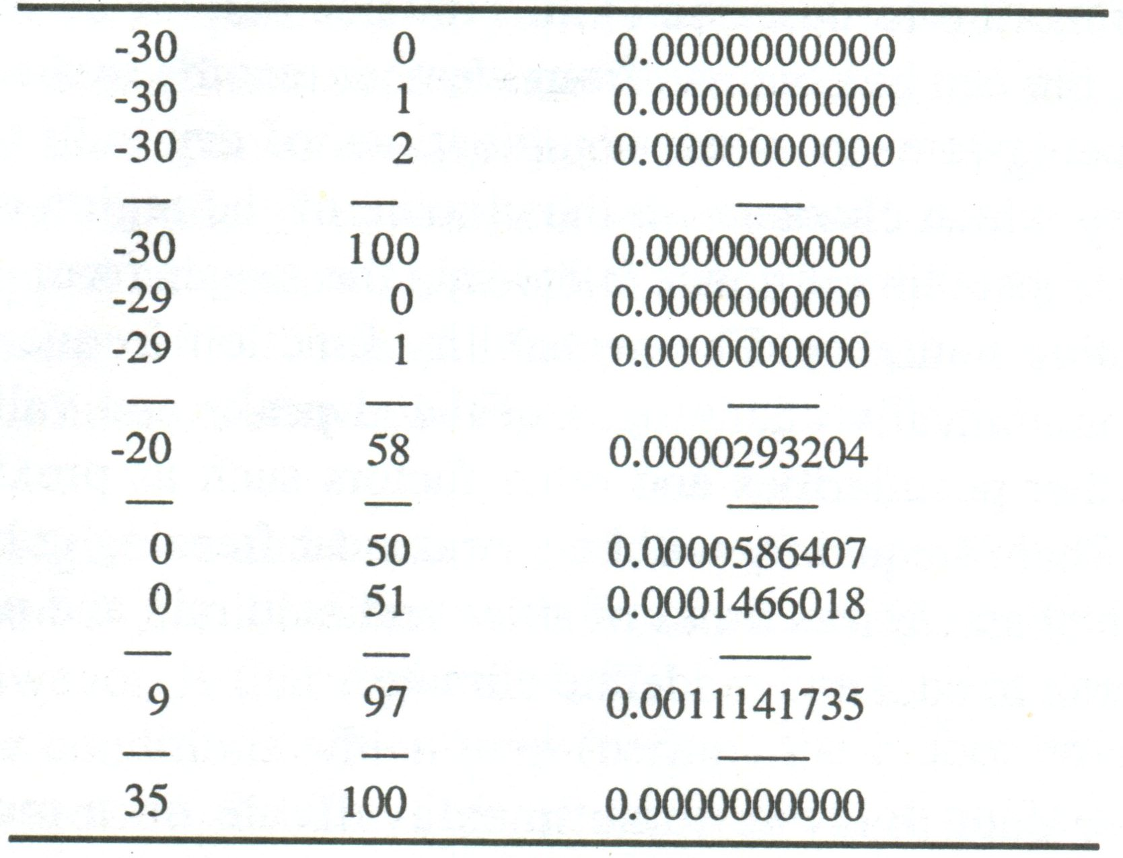

10-6.2. Example use of WEATHER

Example 10-5. 假設如範例 9-4所述的乳牛舍位於海拔 300m的紐約州綺色佳，牛舍飼養了62頭平均重量為 550 kg 的乳牛，其 UA 與FP 值分別為 640 與 105 W/K。生產空間為 5 ~ 25 度C，30~80 % RH，各階段風量分別為 1.16, 1.74, 2.88, 4.24 與8.96 m³/s，各階段溫度設定點分別為 8, 12, 16 與 20度C，請問此設計是否適當？
Consider the barn described in Example 9-4, to be located near Ithaca, NY, and to house 62 milking cows averaging 550 kg body mass. A five-stage ventilation system is planned, with the ventilation stages described in the example (1.16, 1.74, 2.88, 4.24, and 8.96 m³/s). The barn will be located at an elevation 300 m above sea level, and have ΣUA and FP values of 640 and 105 W/K, respectively. The Production Space is between 5 and 25 C, and 30 and 80% relative humidity. Thermostat setpoints of 8, 12, 16, and 20 C will be specified. Determine how well this design will provide the cows with conditions within the PS.

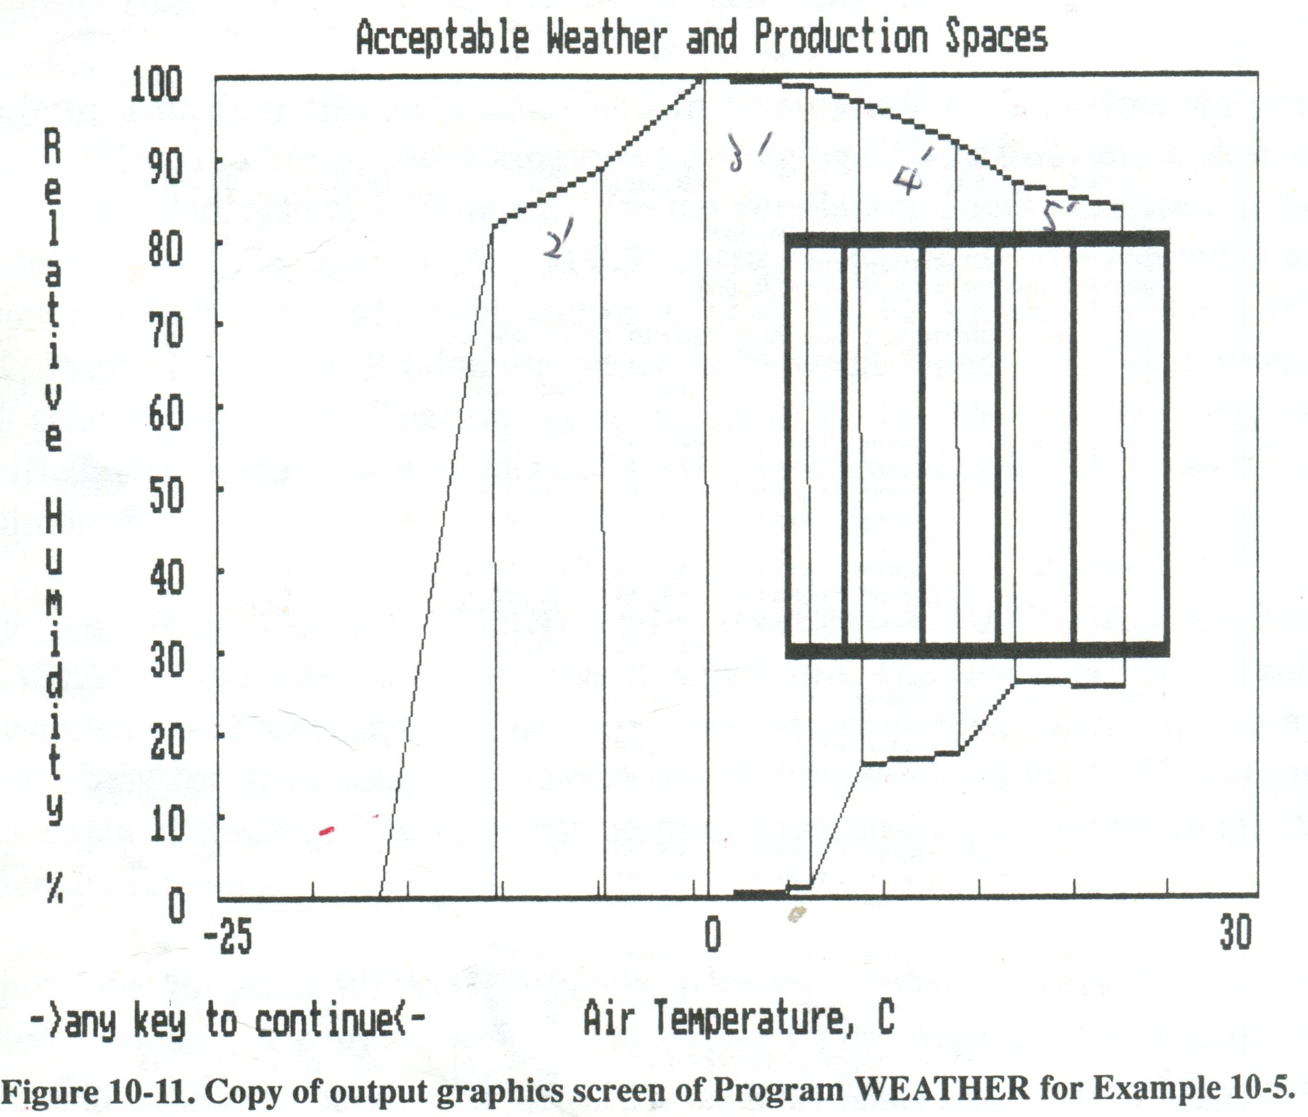
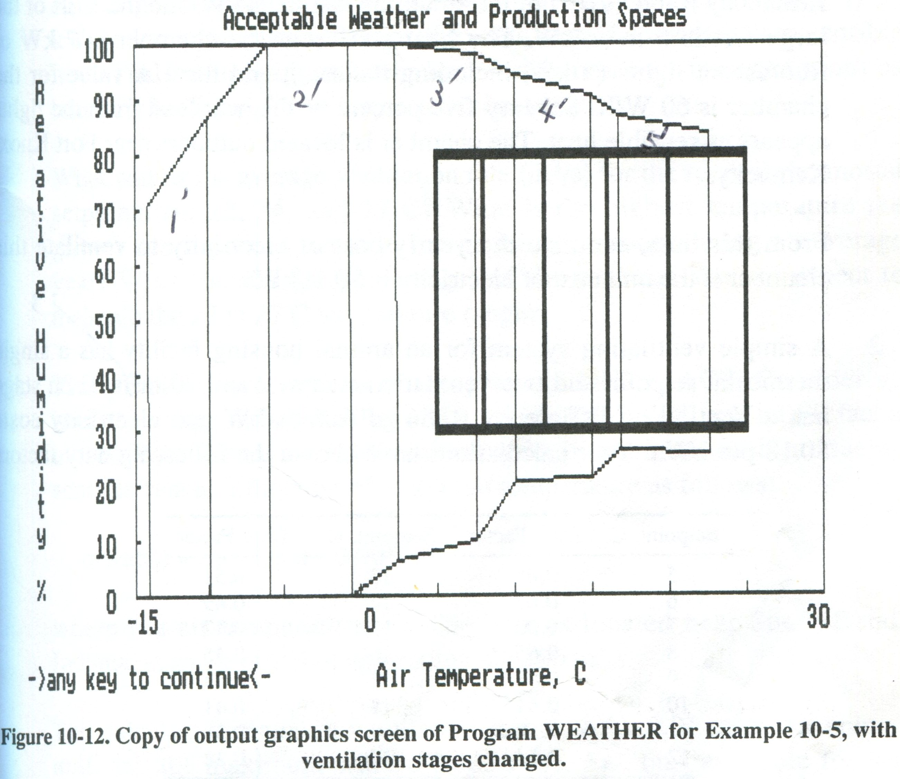

10-7. Ventilation Control in Greenhouses

- 在相同地區溫室所用的風扇的duty factor 應比禽畜舍中所用風扇的duty factor 較小，因為不需全年操作。.
- 對溫室而言，因為作物的適溫範圍頗為狹窄，所以在控制器的溫度設定值上做變化以節約耗電量的可行性就小多了。只有在一開始選擇風扇時挑選效率高的風扇並注意時時維護保持風扇於最佳的操作性能才是最重要的。維護項目包括皮帶鬆緊度、軸承、百葉窗等。
- 溫室通風的設計通常設定為3個階段(3-stage system)，最低階段為冬季通風之用，為最大風量的15%，第2階段則多半為最大風量的50% 。
- 通風的最低設定溫度應高於開始加熱的設定溫度至少3度C。

補充：Check the Vent_Cost, TaiWeather (matlab 版), WeaPlot (DOS 版) 等程式。
Chap. 10 Homework

- A plant growth chamber is be ventilated with a two-stage ventilation system. When the temperature in the chamber is below 20 C, a small fan (0.5 m³/s) is used. When the chamber’s temperature is above 20 C, the smaller fan is inactivated and a larger fan (5 m³/s) is used. The Ventilating Efficiency Ratio (VER) of the small fan is 2 m³/s-kW, and the VER of the large fan is 5 m³/s-kW. The heat source in the chamber is 2kW of fluorescent lights (2 Kw, including ballasts), and the UA value for the chamber is 60 W/K. Seventy-five percent of the heat load from the lights appears as sensible heat. The chamber is located outdoors near Fort Knox, Kentucky.
From this data, estimate the yearly cost of electricity to ventilate this chamber if the unit cost electricity is $0.11/kWh.
- A simple ventilating system for an animal housing facility has a single thermostat setpoint and two ventilation stages, 2 and 20 m²/s. Each stage has a Ventilating Efficiency Ratio of 6 m³/s-kW and electricity costs $0.18 per kWh. Your calculations have shown the following duty factors for the ventilation system as a function of the thermostat setpoint (to switch between the two stages):
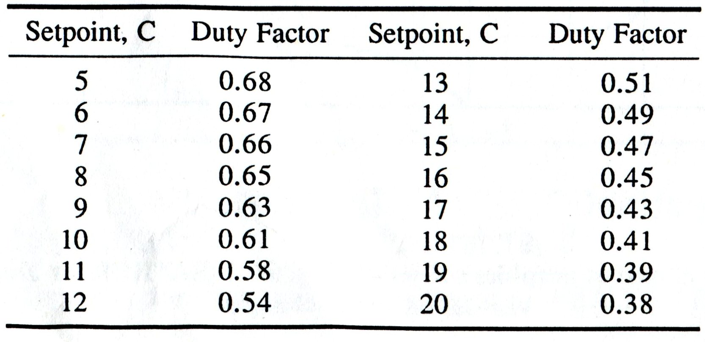
The production of the animals is also a function of indoor air temperature (the setpoint). Data have shown net income (excluding the cost of ventilation) as a function of air temperature is as follow:
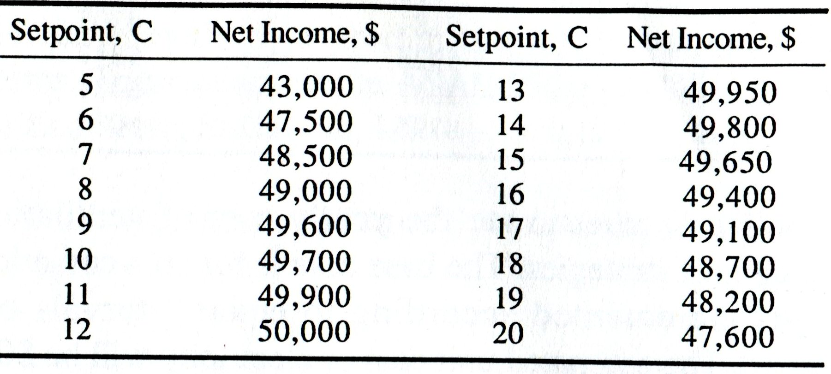
Based on these data, what is the thermostat setpoint for highest profitability?
- A greenhouse operator in Eugene, Oregon has a separate small building for germinating seeds. Flats of soil are seeded, placed in this building under lights for 10 days, and then taken from the building where the seedlings are transplanted into pots and moved to the greenhouse.
The germination room is well insulated (ΣUA + FP = 65 W/K) and is ventilated using fans in four stages: 0.5, 1.0, 2.0, and 5.0 m³/s (total for each stage). The heat load in the room is from lights; total wattage is 50 kW, and it is estimated 70% of the total heat is converted into sensible heat. The rest appears as latent heat and is removed from the room as humidity in the air. There are no other heat sources.
What will be the average ventilation rate (m³/s) for the room if thermostat setpoints are 22, 24, and 27 C? What is the highest temperature the grower can expect to occur in the germination room during an average year? What fraction (or percentage) of the year can she not expect to maintain the 22 to 27 C temperature range?
- This problem involves use of the program DUTYFACT. Consider an animal housing facility having a UA value of 850 W/K and an FP factor of 180 W/K. There are 1300 animal units in the barn, each producing sensible heat as a function of indoor air temperature as follows:
q( watts ) = 58 – 1.33t – 0.0052t²
where t is air temperature, C. The barn is located near South Bend, Indiana, at an elevation of approximately 200 m.
The calculated minimum ventilation rate is to be 0.01 m³/s per animal unit, and the maximum will be 0.085 m³/s. The fans available for use have the following performance data. Note: The airflow data are in cfm and the VER data are in cfm/watt. See the note at the end of the problem statement for conversion factors.
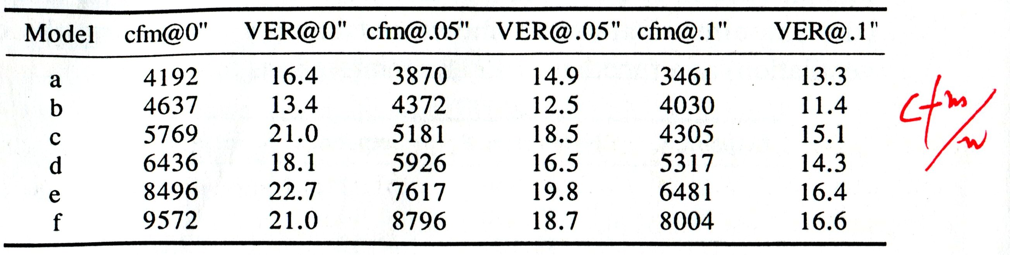
This problem is to estimate the yearly cost of ventilation for several possible control strategies. The base is for six ventilation stages, with the stages incremented according to equal intervals of outdoor air temperature. The estimated unit cost of electricity will be $0.09/kWh.
Another possibility is to stage the fans according to even increments of ventilation rate using a six-stage system. Determine the yearly cost of ventilation for this possibility.
For both designs, use setpoints of 13, 16, 19, 22, and 25 C.
Think about why the difference in duty factors and costs should arise.
For selecting fans, assume there will be six fan banks. This should not dictate fan selection, but the expected number of fan banks should be kept in mind when selecting fans so the end results are approximately symmetrical among the fan banks.
Note: This problem and DUTYFACT are based on the SI system. Fan data is available today in the US in IP units. One way to approach the disparity is to convert all fan data to SI units. Conversion factors are:
2119 cfm = 1.0 m³/s; 2.119 cfm / W = 1.0 m³/s-kW

